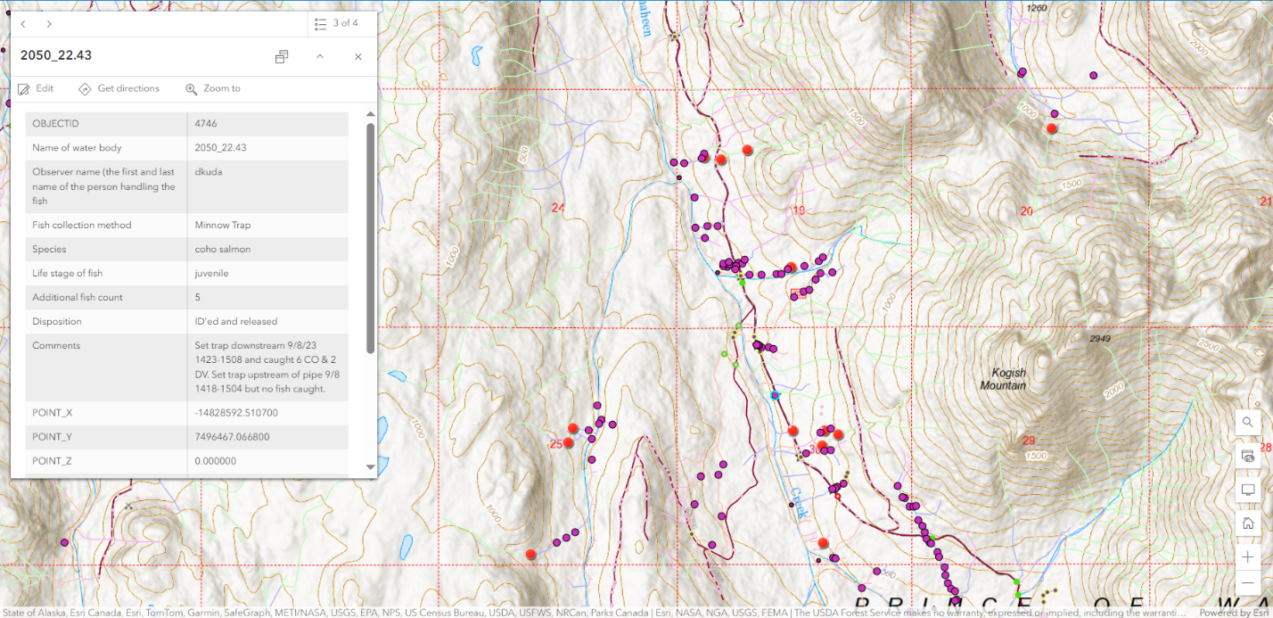

Figure . Area map Shaheen tributary (2050 MP 22.43) 6 CO juvs Fish Observation Pt (blue halo) 9/8/2023.

Figure . Location map 6 CO juvs Fish Observation Point (blue halo) on 9/8/2023.

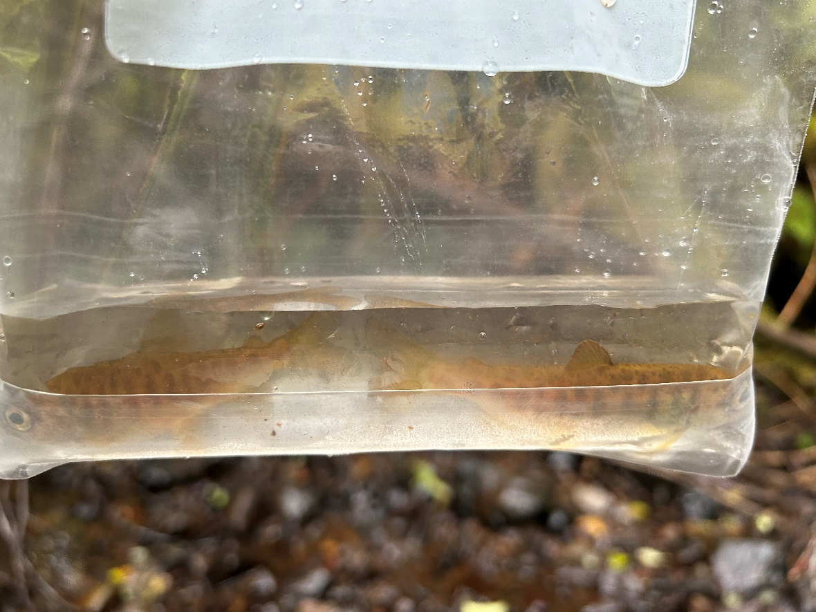

Figure . Photo of 2 CO juvs Shaheen Cr tributary at 2050 MP 22.43.

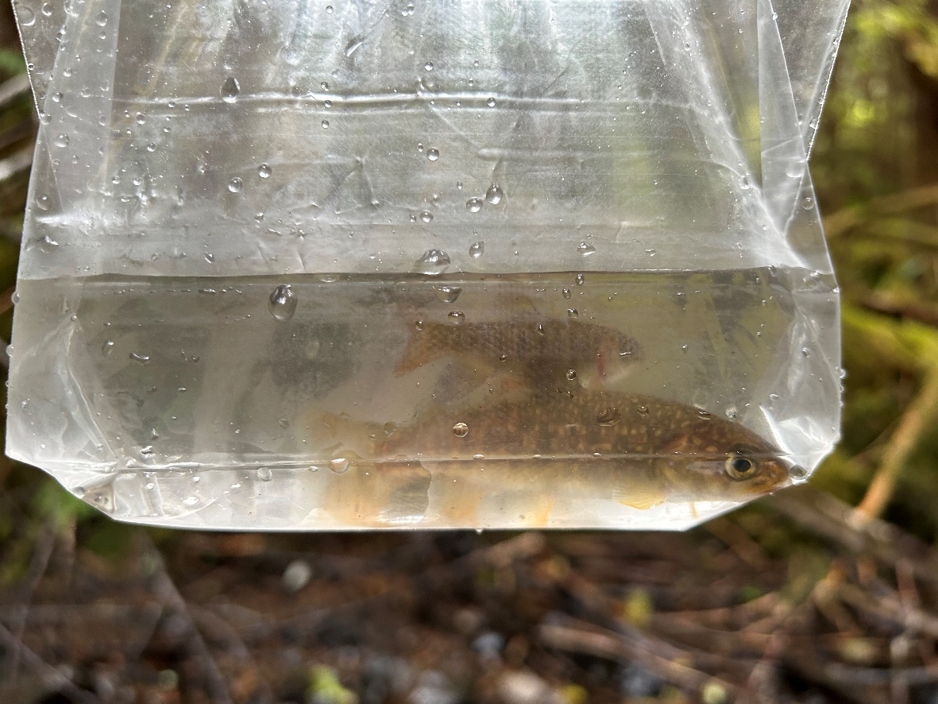

Figure . Photo of 1 CO & 1 DV juvs at Shaheen Cr tributary 2050 MP 22.43.